**Vœux 2018**



Toute l’équipe de vous souhaite

d’excellentes fêtes de fin d’année.

Puisse-t-elle vous apporter joie, santé et bonheur. En particulier que l’année 2018 soit pour vous riche en découvertes nouvelles et idées enrichissantes.



|  |  |  |  |  |  |
| --- | --- | --- | --- | --- | --- |
|  | H | P | P | Y |  |
| Ne | W |  | Y | E | Ar |

[](https://www.google.be/imgres?imgurl=https%3A%2F%2Fs-media-cache-ak0.pinimg.com%2Foriginals%2Fd7%2F3d%2Fea%2Fd73dea3a89ca136883b6efb1b239e76a.png&imgrefurl=https%3A%2F%2Fwww.pinterest.fr%2Fpin%2F785174516257472603%2F&docid=1udZDwPlqackqM&tbnid=9ikvkFZ6H2-RrM%3A&vet=10ahUKEwigrL--qoTYAhXjD8AKHWyCDJE4ZBAzCAkoBzAH..i&w=710&h=444&bih=906&biw=1280&q=images%20happy%20new%20year%202018%20%C3%A0%20imprimer&ved=0ahUKEwigrL--qoTYAhXjD8AKHWyCDJE4ZBAzCAkoBzAH&iact=mrc&uact=8)

[](https://www.google.be/url?sa=i&rct=j&q=&esrc=s&source=images&cd=&cad=rja&uact=8&ved=0ahUKEwjU_fiDrYTYAhXhDsAKHRYyCRAQjRwIBw&url=https%3A%2F%2Ffr.fotolia.com%2Ftag%2F%2522bonne%2520ann%25C3%25A9e%2522&psig=AOvVaw2fMdTuKVpPxFMzpMqvcvne&ust=1513163133473155)

[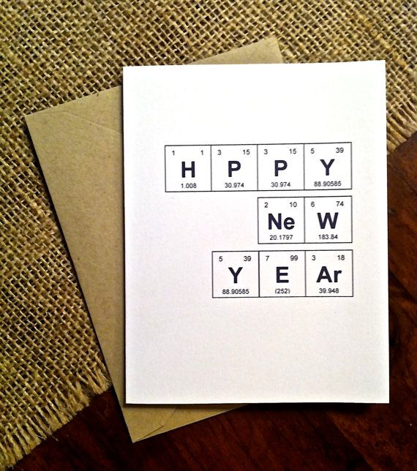](https://www.google.be/url?sa=i&rct=j&q=&esrc=s&source=images&cd=&cad=rja&uact=8&ved=0ahUKEwif76u_rYTYAhWMA8AKHf1PBv0QjRwIBw&url=https%3A%2F%2Fwww.pinterest.com%2Fexplore%2Fnew-year-card%2F&psig=AOvVaw3PCmXiqNKENHQ_6lO6U56N&ust=1513163989287217)

[](https://www.google.be/url?sa=i&rct=j&q=&esrc=s&source=images&cd=&cad=rja&uact=8&ved=0ahUKEwiqjdvh6IXYAhUmJMAKHdFCCdQQjRwIBw&url=https%3A%2F%2Fwww.pinterest.com%2Fpin%2F497084877601141390%2F&psig=AOvVaw3PCmXiqNKENHQ_6lO6U56N&ust=1513163989287217)

[](https://www.google.be/url?sa=i&rct=j&q=&esrc=s&source=images&cd=&cad=rja&uact=8&ved=0ahUKEwjBg8b76IXYAhWLL8AKHZYWD0MQjRwIBw&url=https%3A%2F%2Fwww.fotolia.com%2Fid%2F104008680&psig=AOvVaw3PCmXiqNKENHQ_6lO6U56N&ust=1513163989287217)

[](https://www.google.be/url?sa=i&rct=j&q=&esrc=s&source=images&cd=&cad=rja&uact=8&ved=0ahUKEwjBg8b76IXYAhWLL8AKHZYWD0MQjRwIBw&url=https%3A%2F%2Fwww.istockphoto.com%2Fvector%2Flogos-for-laboratories-and-scientific-organisations-gm585521134-100433531&psig=AOvVaw3PCmXiqNKENHQ_6lO6U56N&ust=1513163989287217)



